Name: Tushar Muley

Assignment: Exercise 6.2 histogram, box plot, bullet chart, and 1 additional chart of your choice

Date: November 20, 2021

**Power BI Histogram chart:**

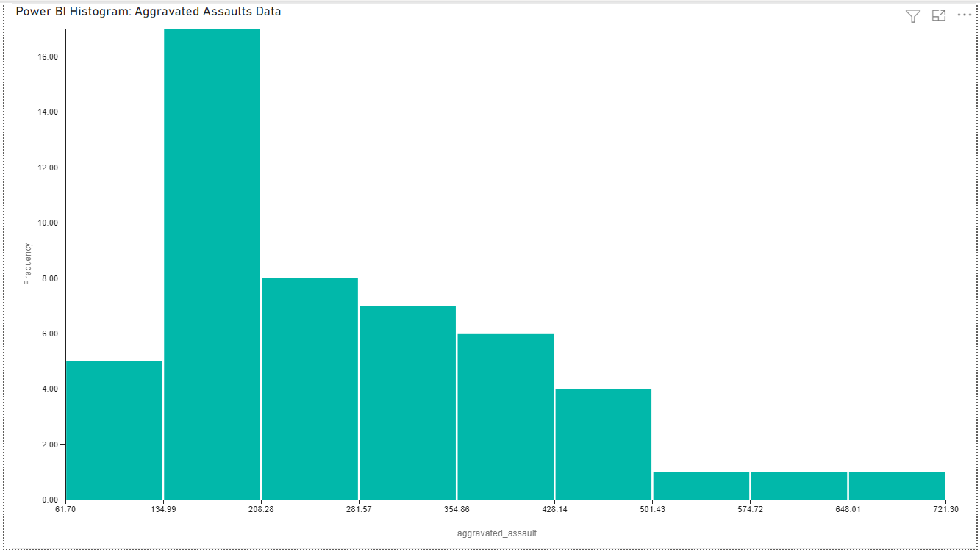

**Power BI Box plot:**

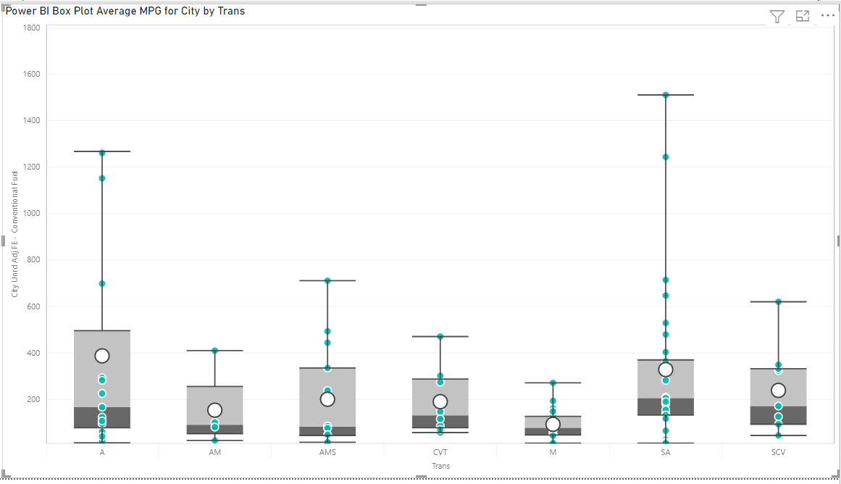

**Power BI Bullet Chart:**

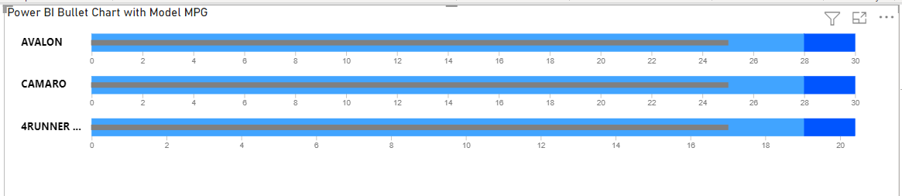

**Power BI My choice:**

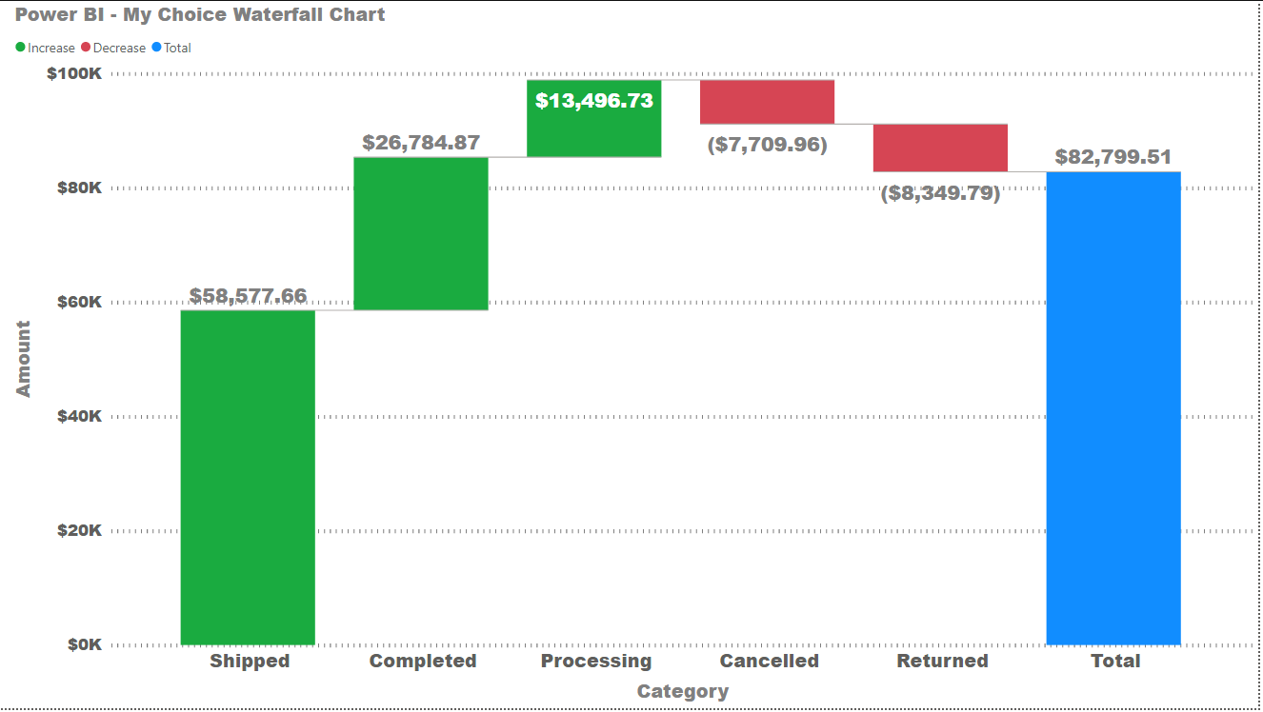

**Python Histogram:**

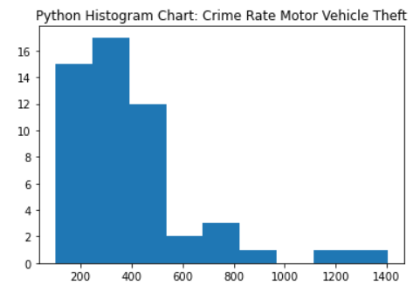

**Python Box Plot:**

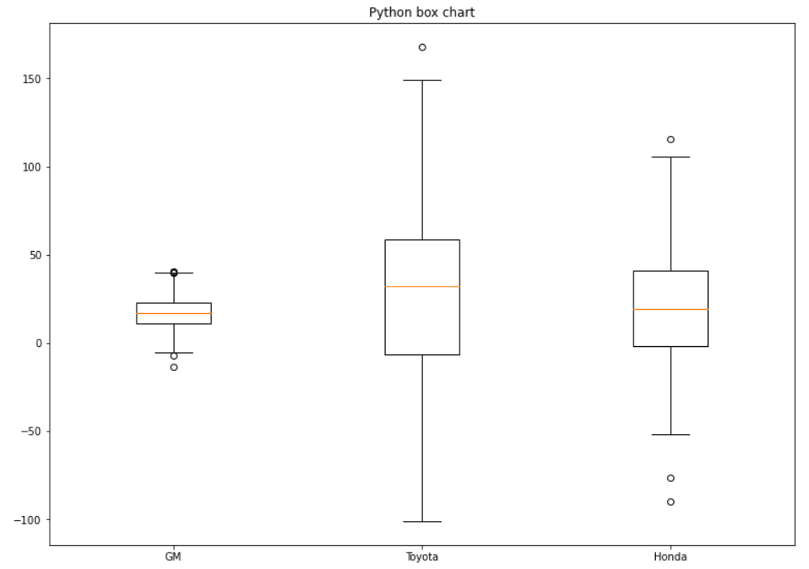

**Python Bullet Chart:**

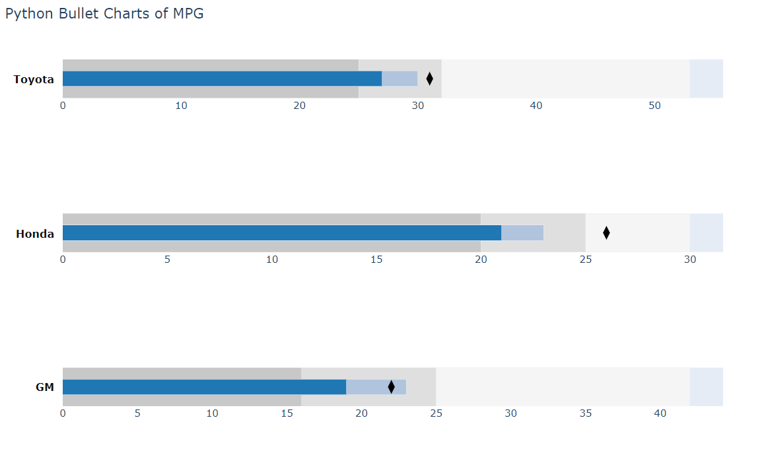

**Python My Choice Chart:**

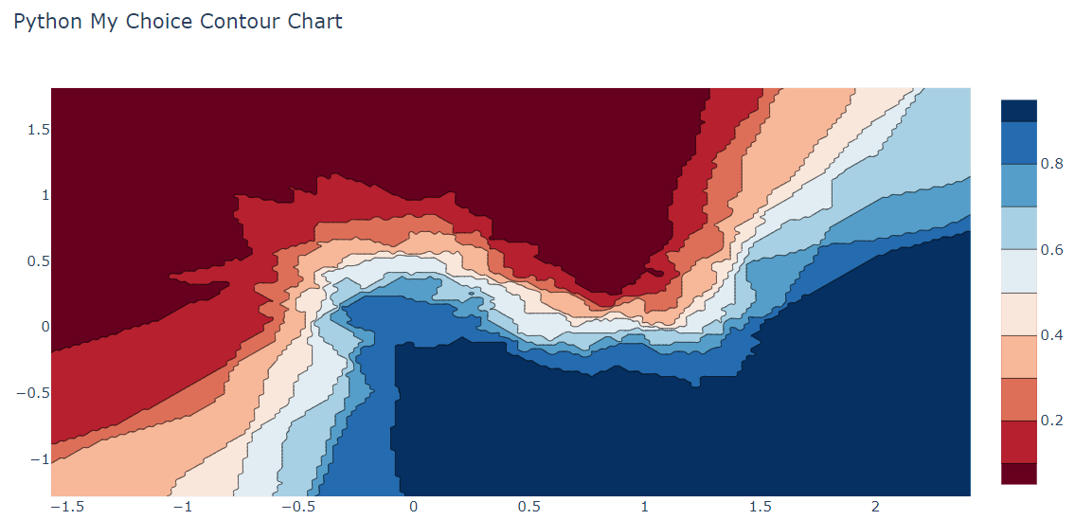

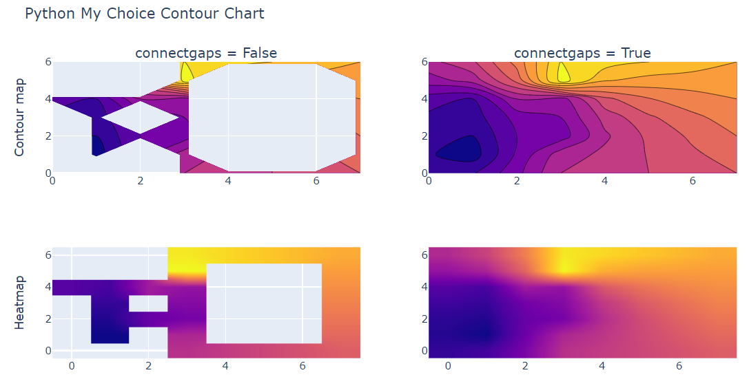

**R Histogram:**

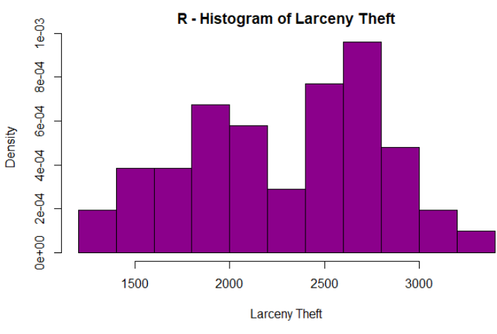

**R Box plot:**

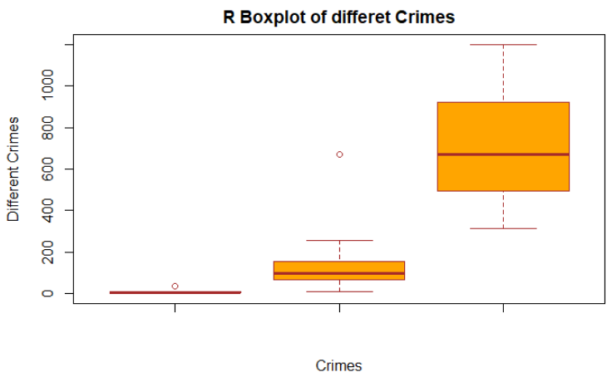

**R Bullet plot:**

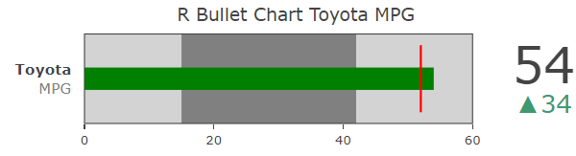

**R my Choice Chart:**

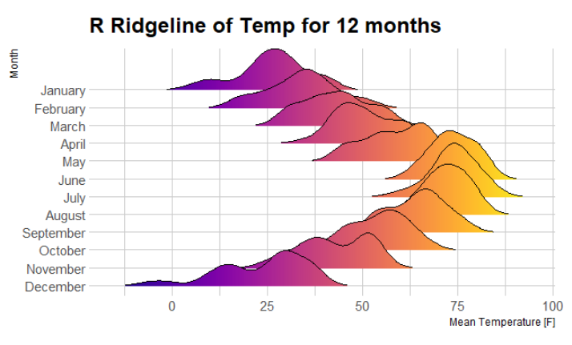

**The above chart produced once. I tried to produce a PDF and it never worked. Cause errors.**

